**PROJECT NAME – MYNTRA (Online shopping site)**

**Overview**: It’s an ecommerce website for both men and women where you can buy dresses and home related things. Here is the url -- https://www.myntra.com

**Home Page**: Contains – navbar(dropdown), logo, banner, cards(image), search popup login form and description, footer etc.

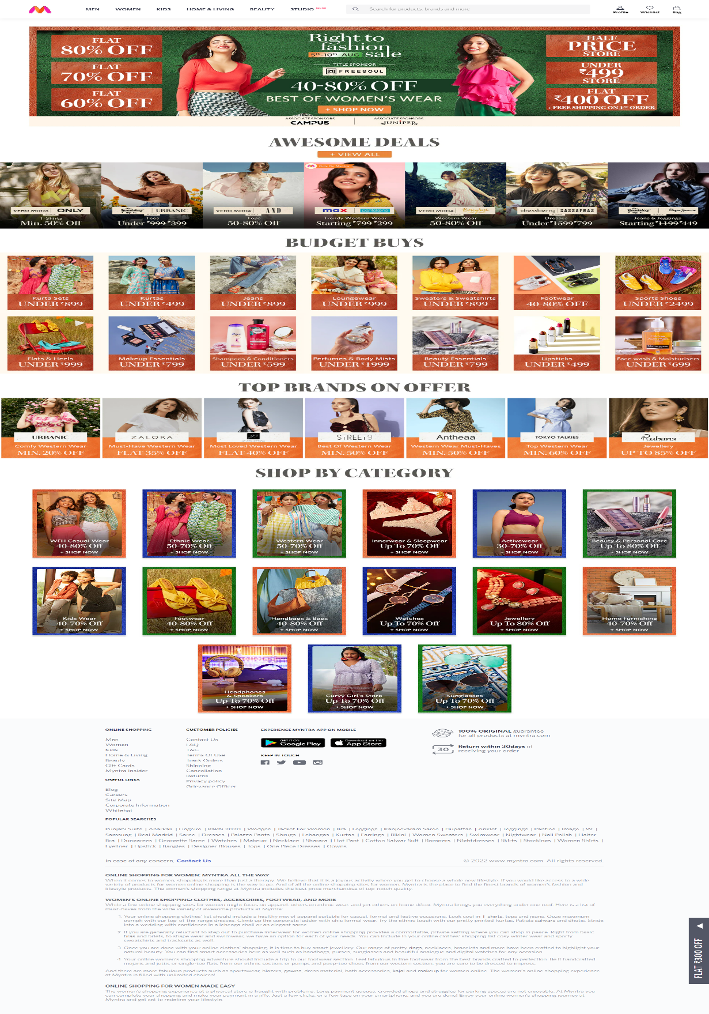

**Listing Page**: Contains – filter, dropdown breadcrumbs, search,navbar,sort option, cards(items related to category), footer, etc…

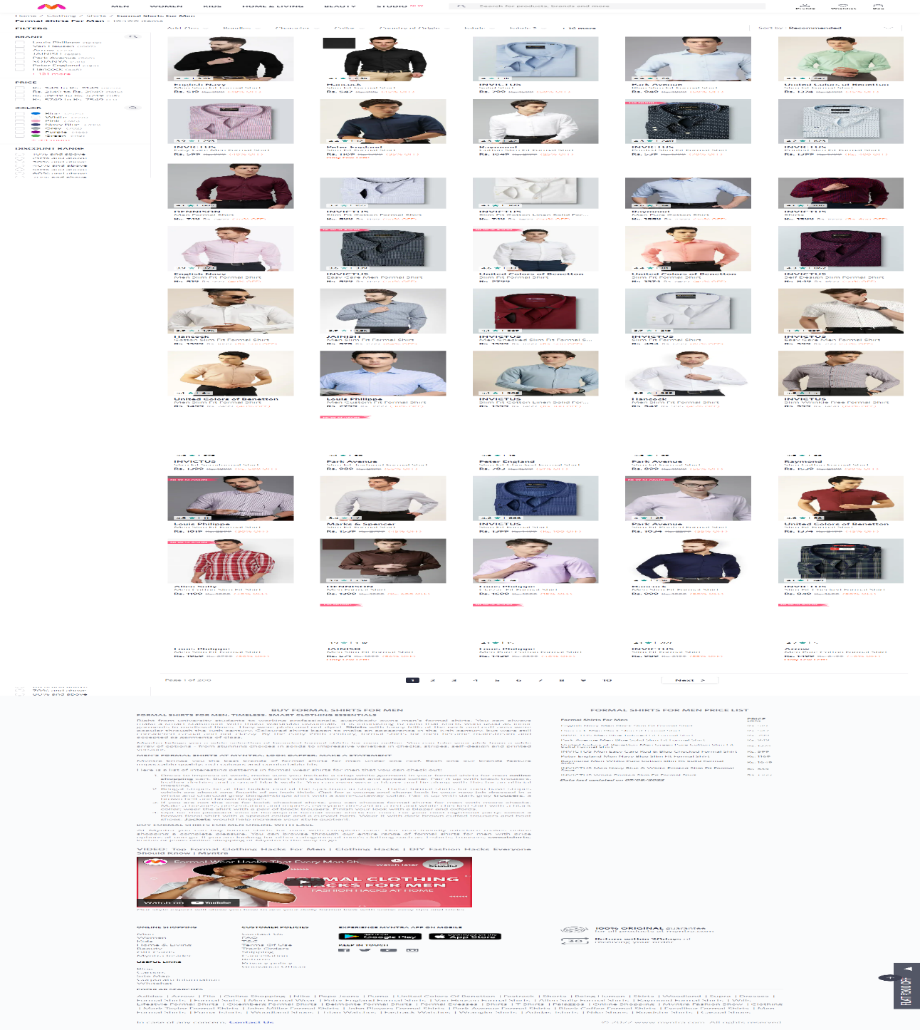

Few Important points.

* I added to only a sample listing page as other listing pages are also of same structure
* For every product the format of the listing page is same it contains cards.
* Footer is common for every page and it contains some description

**Full Details**: contains – price, add to bag, Wishlist , product description, rating , payment gateway etc..

